Prayers of the Rosary

In the name of the Father, the Son and The Holy Spirit (Make the Sign of the Cross)

1. Apostles’ Creed (Hold the Crucifix)
I believe in God, the Father Almighty,
Creator of heaven and earth;
I believe in Jesus Christ, His only Son, our Lord:
who was conceived by the Holy Spirit, born of the Virgin Mary; suffered under Pontius Pilate, was crucified, died and was buried.
He descended into hell;
the third day He rose again from the dead.
He ascended into heaven, and is seated at the right hand of God the Father Almighty.
From thence He shall come to judge the living and the dead.
I believe in the Holy Spirit, the Holy Catholic Church, the communion of Saints, the forgiveness of sins,
the resurrection of the body, and life everlasting.
Amen

2. Announce the Mystery and Reflect. (One before each decade begins. Hold the large/single bead)

3. Our Father (Recite on each large/single bead)
Our Father, Who art in heaven
Hallowed be Thy Name;
Thy kingdom come,
Thy will be done,
on earth as it is in heaven.
Give us this day our daily bread,
and forgive us our trespasses,
as we forgive those who trespass against us;
and lead us not into temptation,
but deliver us from evil. Amen.

4. Hail Mary (Recite 10 using small beads)
Hail Mary, full of grace.
The Lord is with thee.
Blessed are thou among women,
and blessed is the fruit of thy womb, Jesus.
Holy Mary, Mother of God, pray for us sinners,
now and at the hour of our death. Amen
5. The Glory Be (Said after each decade)
Glory be to the Father and to the Son
and to the Holy Spirit.
As it was in the beginning is now,
and ever shall be, world without end. Amen.
6. Fatima Prayer (Follows each Glory Be)
O, my Jesus, forgive us our sins;
save us from the fires of hell.
Lead all souls to Heaven,
especially those who are most in need of
Thy Mercy.

7. Hail Holy Queen (Hold the Medallion)
Hail, holy Queen, Mother of Mercy,
our life, our sweetness, and our hope!
To thee do we cry, poor banished children of Eve. To thee do we send up our sighs, mourning and weeping in this valley of tears.
Turn, then, most gracious advocate,
thine eyes of mercy toward us; and
after this our exile show unto us the
blessed fruit of thy womb Jesus;
O clement, O loving, O sweet Virgin Mary.
___
Leader: Pray for us, oh holy Mother of God
___
Response: That we may be made worthy of the
promises of Christ.

In the name of the Father, the Son and the Holy Spirit Make the Sign of The Cross

Concluding prayers that are often said at
Christ King Parish (optional)

Memorare
Remember, O most gracious Virgin Mary,
that never was it known that anyone
who fled to Thy protection,
implored Thy help,
or sought Thy intercession was left unaided.
Inspired by this confidence,
I fly unto thee,
O Virgin of virgins, my Mother;
to thee do I come; before thee I stand,
sinful and sorrowful.
O Mother of the Word Incarnate,
despise not my petitions,
but in thy mercy hear and answer me. Amen.

Let Us Pray
O God, whose only–begotten Son,
by His life, death and resurrection,
has purchased for us the rewards
of eternal life;
grant, we beseech Thee, that meditating upon
these mysteries of the most holy rosary of the
Blessed Virgin Mary, we may imitate what
they contain and obtain what they promise,
through the same Christ our Lord. Amen.

Prayer to St. Michael
Saint Michael the Archangel,
defend us in battle.
Be our safeguard against the wiles
the wickedness of the devil.
May God rebuke him,
we humbly pray; and do Thou,
O Prince of the Heavenly Host -
by the Power of God -
cast into hell, satan and all the evil spirits,
who prowl about the world seeking the ruin of
souls. Amen

*Cover Photo from: Jonikmartin.blogspot.com
How to Say the Rosary

- Begin on the crucifix with Apostles Creed.
On the large/single bead pray the Our Father.

- Pray three Hail Marys on the small beads followed by the Glory Be and Fatima Prayer.

- On the next large/single bead Announce the First Mystery and pray the Our Father.

(You may travel either direction on the Rosary)

- Pray ten Hail Marys on the small beads. After the Hail Marys, finish with a Glory Be and the Fatima Prayer.

- On the next large/single bead you will Announce the 2nd Mystery and pray the Our Father followed by ten Hail Marys the Glory Be and the Fatima Prayer.
- Do this series for the five mysteries.

- You will now be at the medallion, pray the Hail Holy Queen. The Rosary is complete.

At Christ King we say some optional prayers after the Hail Holy Queen – they are included.

The Joyful Mysteries (Mondays and Saturdays)
The Annunciation Luke 1:26-28
The Visitation Luke 1:39-41
The Nativity Luke 2:7
The Presentation of the Lord Luke 2:27-30
The Finding in the Temple Luke 2:46-47
The Luminous Mysteries (Thursdays)
The Baptism of Jesus Matthew 3:16
The Wedding Feast at Cana Matthew 2:4-5, 11
Proclamation of the Kingdom of God
Mark 1:14-15
The Transfiguration Luke 9:29, 35
The Institution of the Eucharist Mark 26:26
The Sorrowful Mysteries (Tuesdays and Fridays)
The Agony in the Garden Matthew 26:39
The Scourging at the Pillar Mark 15:15
The Crowning with Thorns John 19:2-3
The Carrying of the Cross John 19:17
The Crucifixion Luke 23:33-34
The Glorious Mysteries (Wednesdays and Sundays)
The Resurrection John 20:8-9
The Ascension Luke 24:50-51
The Descent of the Holy Spirit Acts 2:3-4
The Assumption of Our Blessed Mother
Judith 13:18
The Coronation of Our Blessed Mother
Revelation 12:1
Praying the Rosary
Christ King Parish
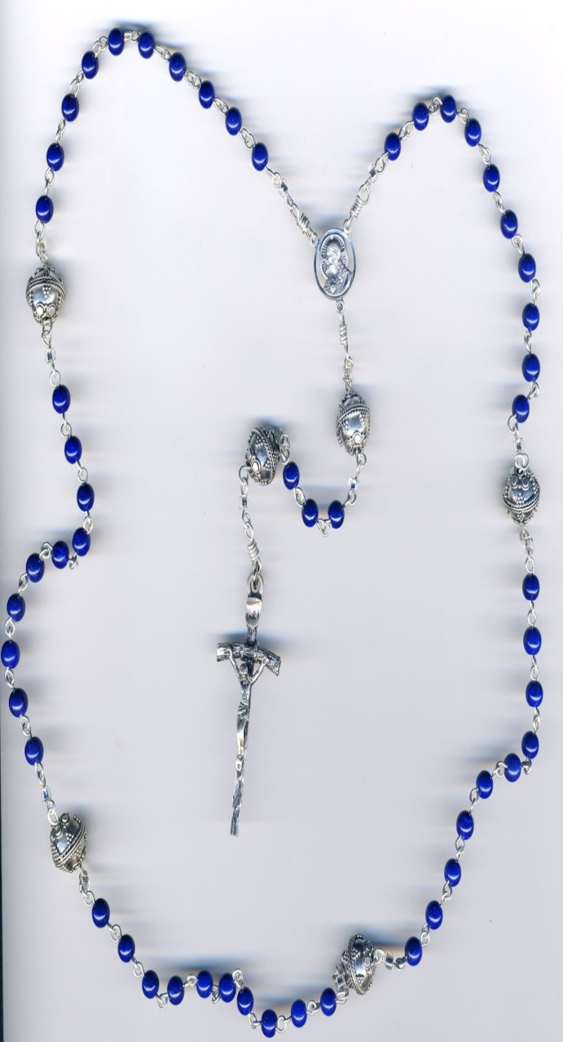
2&3
2&3
4-5-6
4-5-6
4-5-6
4-5-6
4-5-6
4-5-6
2-3

2&3
2&3

7

3

1

*

