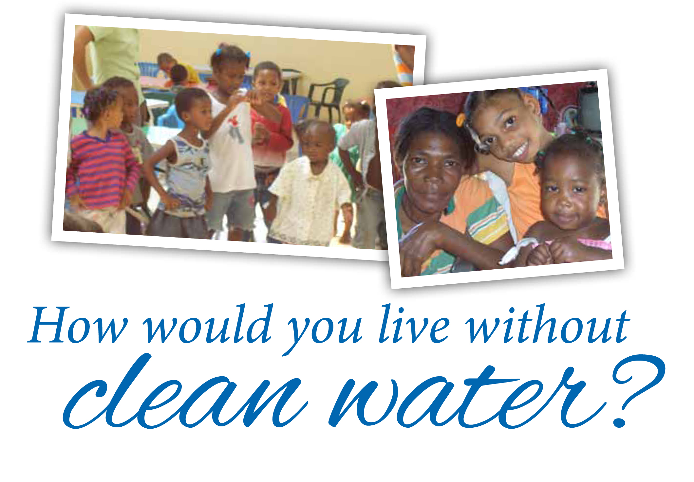
Faith and creativity help our spiritual brothers and sisters
in the Dominican Republic live with joy despite incredibly
harsh conditions.

You can increase hope in La Sagrada Familia, the sister
parish of the Archdiocese of Milwaukee. Even a small $25
donation helps provide food for hungry children, access
to clean water for a family, and education for those working hard to improve their lives.

Learn more about the blessings shared between our
archdiocese and our sister parish—united at the heart for more than 30 years. And make your gift today at worldmissions.archmildonate.org.

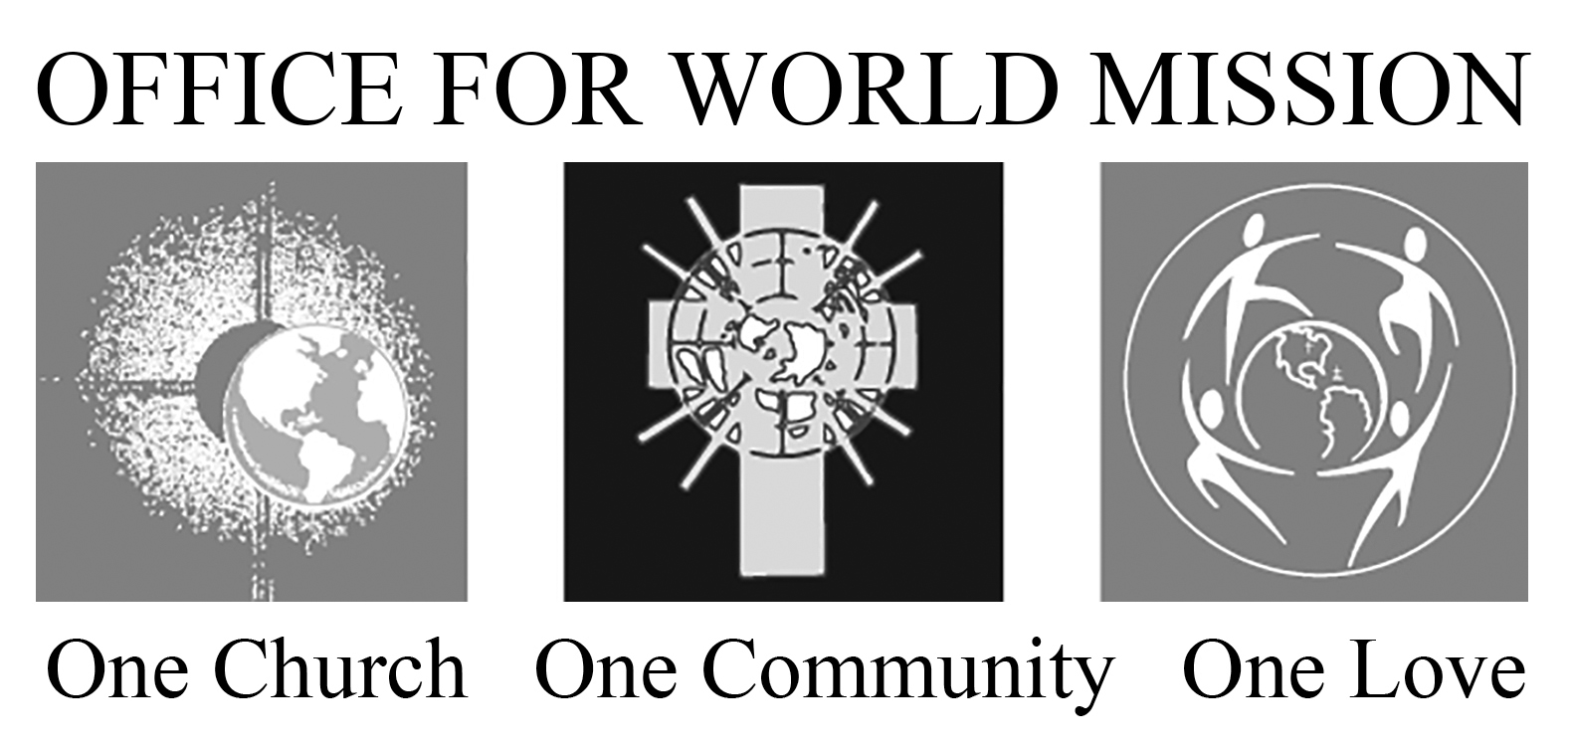

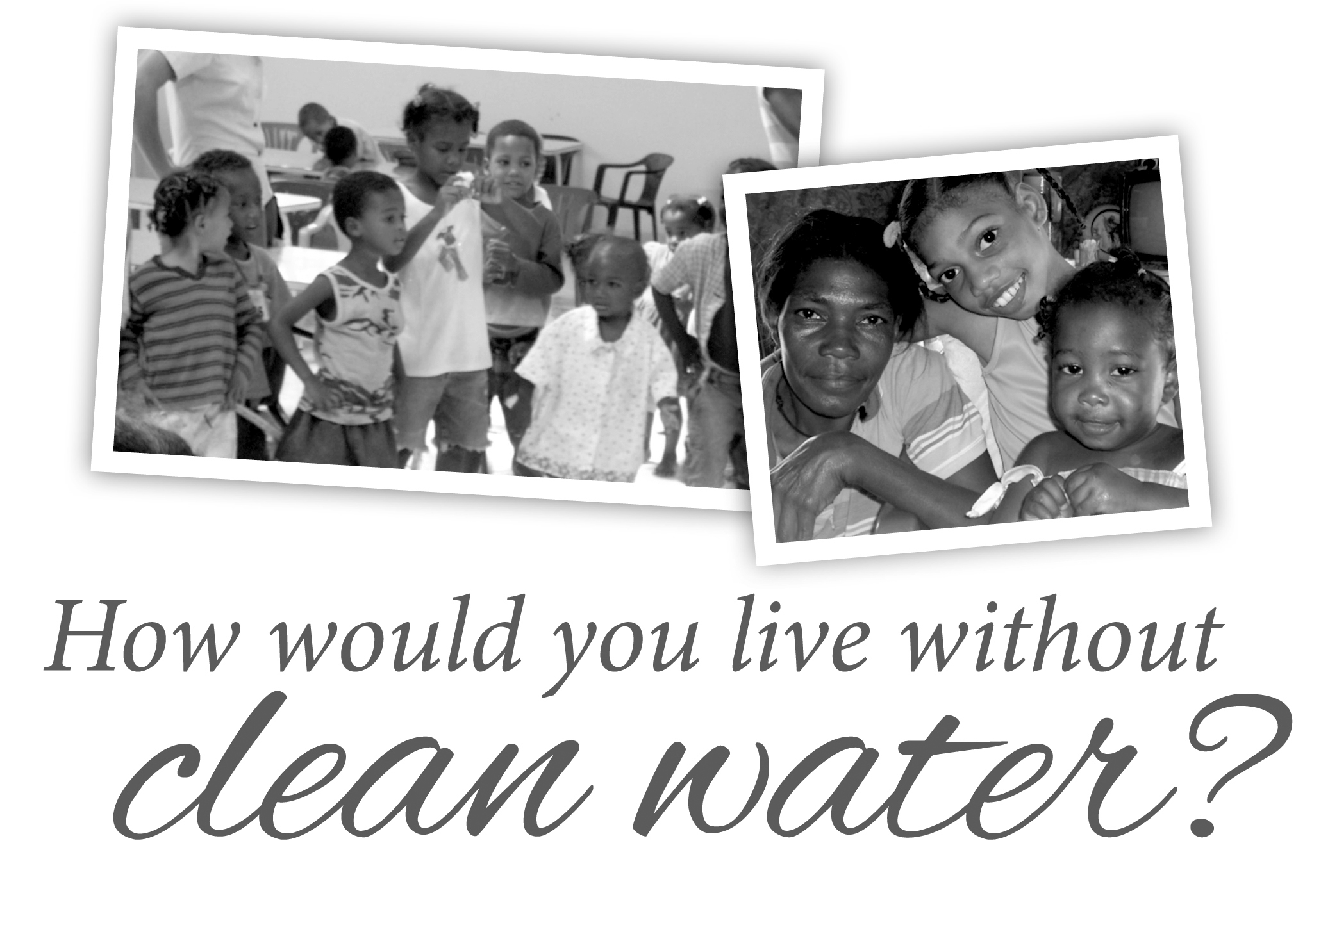
Faith and creativity help our spiritual brothers and sisters
in the Dominican Republic live with joy despite incredibly
harsh conditions.

You can increase hope in La Sagrada Familia, the sister
parish of the Archdiocese of Milwaukee. Even a small $25
donation helps provide food for hungry children, access
to clean water for a family, and education for those working hard to improve their lives.

Learn more about the blessings shared between our
archdiocese and our sister parish—united at the heart for more than 30 years. And make your gift today at worldmissions.archmildonate.org.

