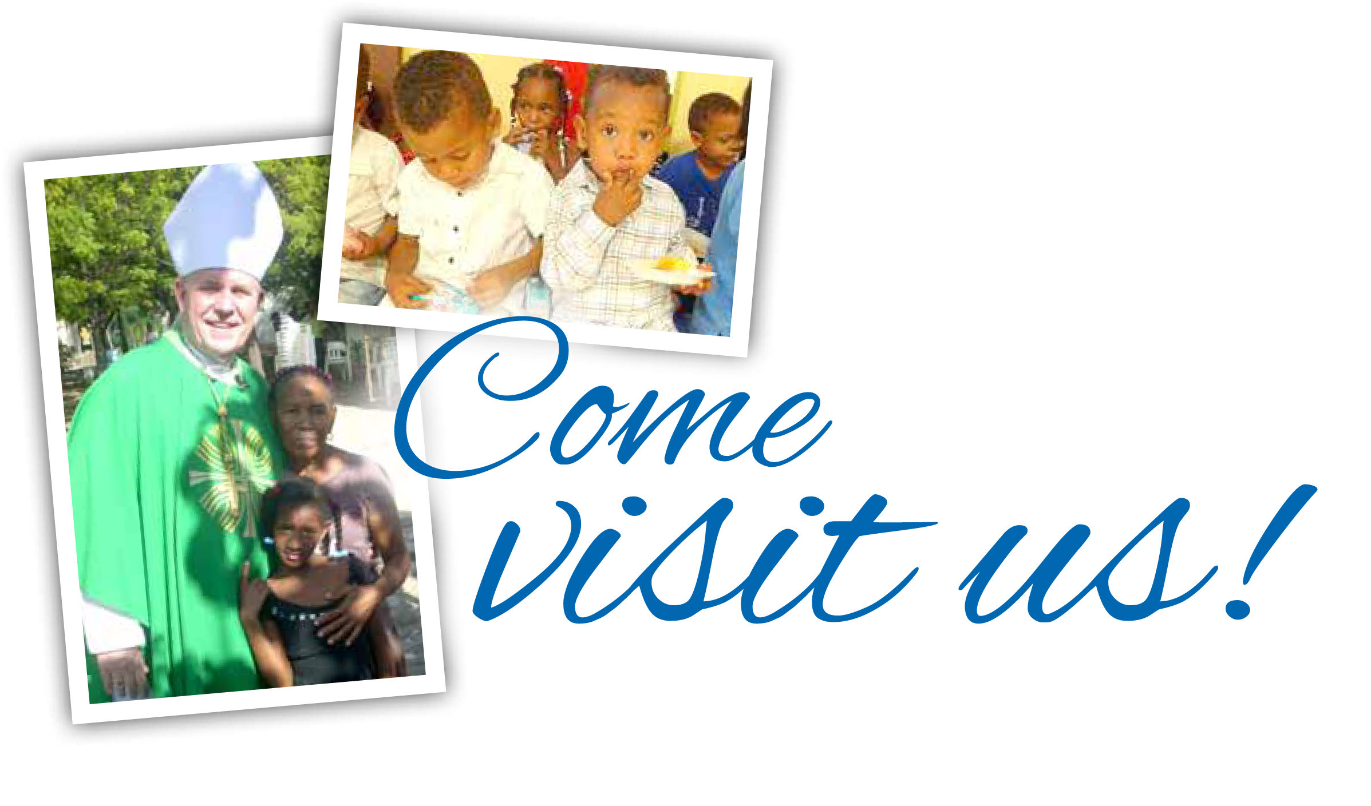
Meet your brothers and sisters from La Sagrada Familia, sister parish of the Archdiocese of Milwaukee. For more than 30 years Wisconsin students, parishioners and priests have spent time together experiencing transformative friendships and faith. We are truly united at the heart.

Even if you can’t make the trip, you can make a difference in this tiny region of the Dominican Republic. Our donations help provide food, medicine, education and job training for people living under incredibly harsh conditions.

Learn more today—give today—and make your plans today to discover your family at La Sagrada Familia: worldmissions.archmildonate.org.

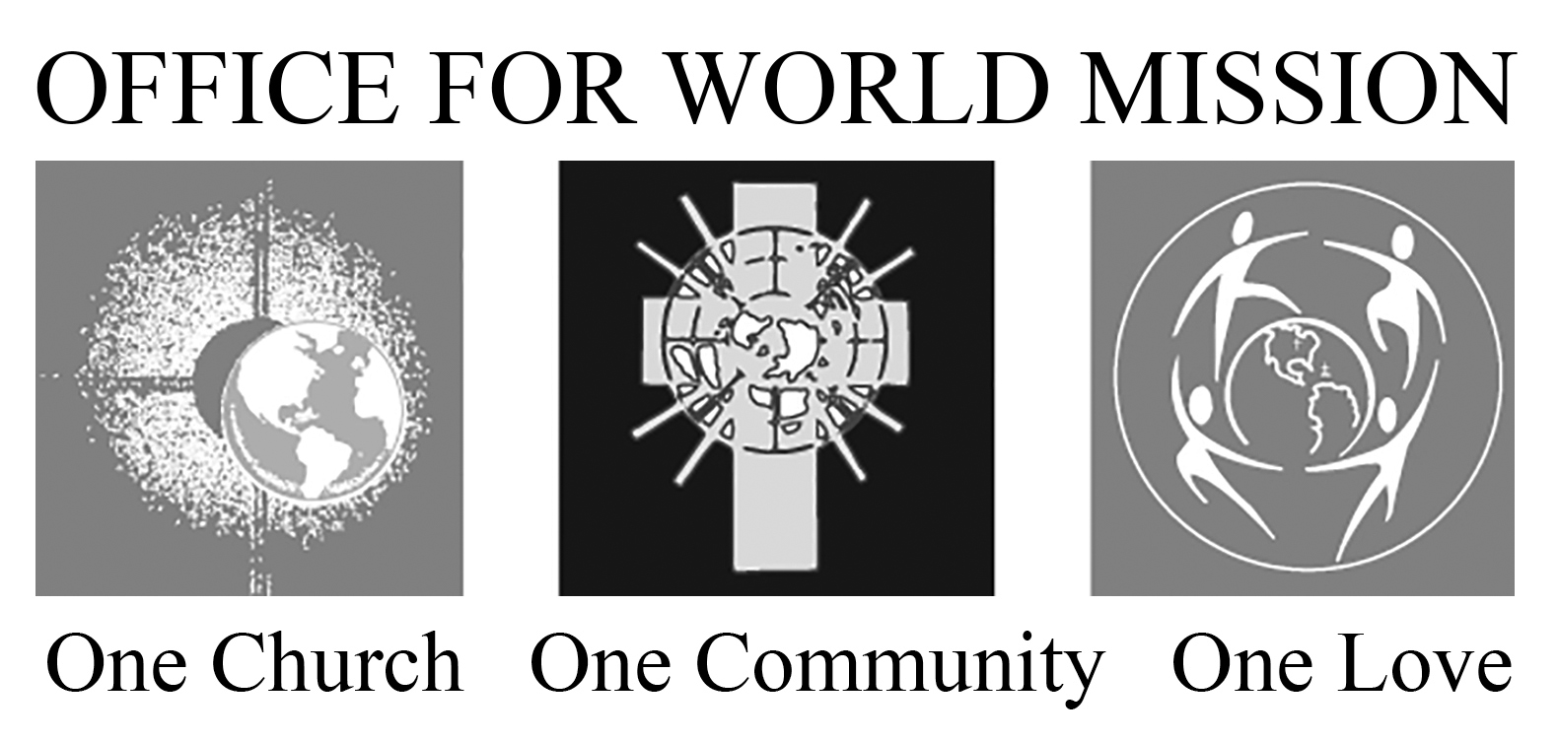

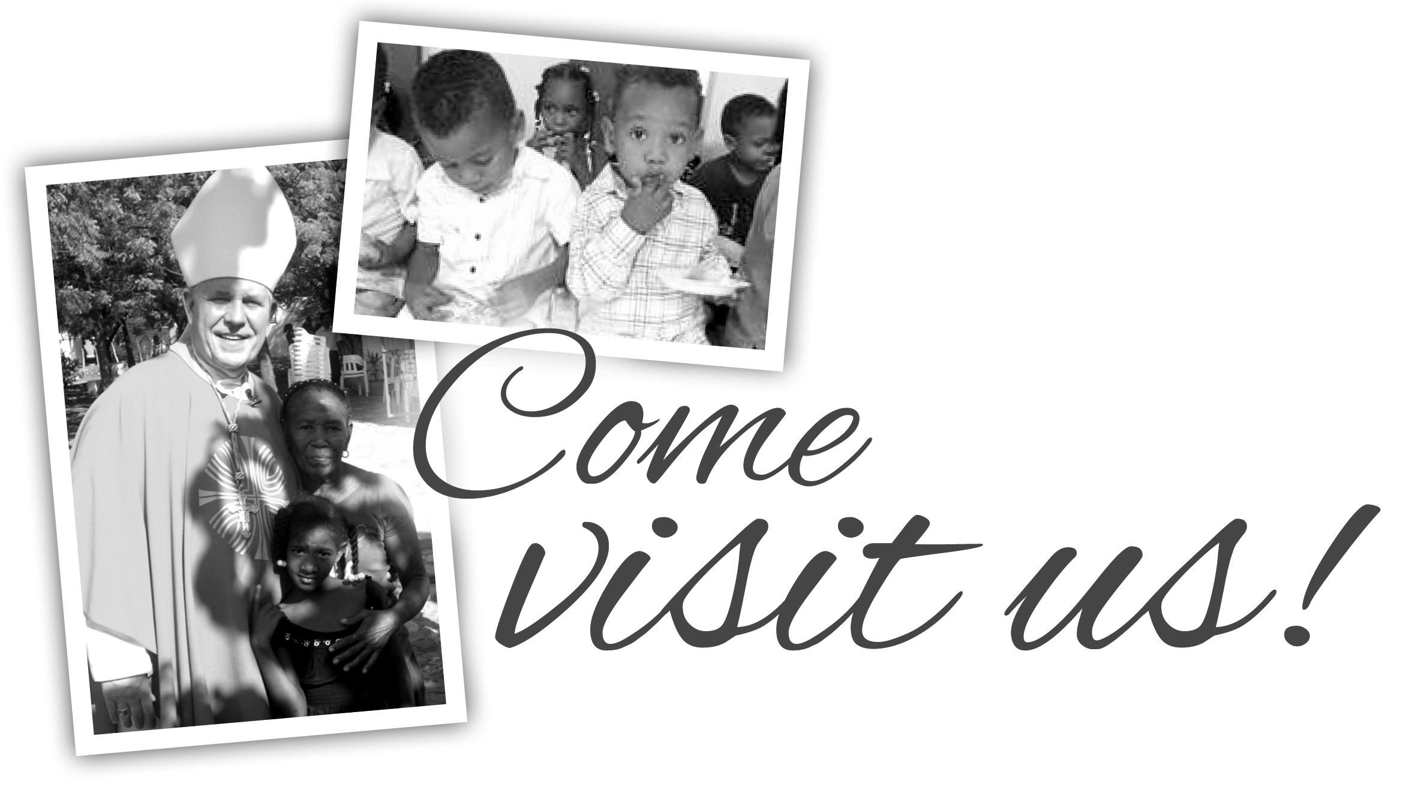

Meet your brothers and sisters from La Sagrada Familia, sister parish of the Archdiocese of Milwaukee. For more than 30 years Wisconsin students, parishioners and priests have spent time together experiencing transformative friendships and faith. We are truly united at the heart.

Even if you can’t make the trip, you can make a difference in this tiny region of the Dominican Republic. Our donations help provide food, medicine, education and job training for people living under incredibly harsh conditions.

Learn more today—give today—and make your plans today to discover your family at La Sagrada Familia: worldmissions.archmildonate.org.

