Stewardship and the
Pope Francis Connection:
Stewardship in the Writings of Pope Francis

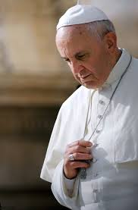
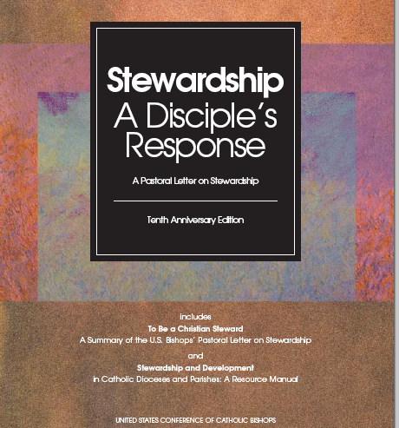
Abbreviations:
PF-date: Pope Francis Tweeted
SDR –Stewardship a Disciple’s Response (page)
EG – Pope Francis in Evangelii Gaudium (paragraph)
LS – Pope Francis in Laudato Si’ (paragraph)
WYD – Pope Francis at World Youth Day

PowerPoint Notes:
Jesus is at the Center
- Christians are witnesses not to a theory, but to a Person: Christ risen and alive, the one Savior of all. (PF 5/28/15)
- Mature disciples make a conscious, firm decision, out in action, to be followers of Jesus Christ no matter the cost to themselves. (SDR p. 5)
- In union with Jesus, we seek what he seeks and we love what he loves. In the end what we are seeking is the glory of the Father; we live and act for the glory of the Father we live an act “for the praise of his glorious grace” (Eph1:6). (EG #267)
Conversion
- Beginning in conversion, change and mind and heart, this commitment is expressed not in a single action, nor even in a number of actions over a period of time, but an entire way of life. It means committing one’s very self to the Lord. (SDR p. 5)
- Thanks solely to this encounter-with God’s love which blossoms into an enriching friendship, we are liberated from our narrowness and self-absorption…For if we have received the love which restores meaning to our lives, how can we fail to share that love with others. (EG# 8)
The Proof is in Our Life
- It is not enough to say we are Christians. We must live the faith not only with our words but with our actions. (PF 1/20/14)
- Once we profess to be a disciple of Jesus, stewardship is not an option. (SDR p.48)
Solidarity
- Faith joins individuals and the community of Jesus’ followers in intimacy with their Lord and leads them to live as disciples. Union with Christ gives rise to a sense of solidarity and common cause between the disciples and the Lord and also among the disciples. (SDR p. 14)
- We must recover the whole sense of gift, of gratuitousness, of solidarity. Rampant capitalism has taught the logic of profit at all costs, of giving to get, of exploitation without looking at the person…we see the results in the crisis we are experiencing. (PF-5/21/13)
- To speak properly of our own rights, we need to broaden our perspective and to hear the plea of other peoples and other regions than those of our country. We grow in a solidarity which “would allow all peoples to become the artisans of their destiny”, since every person is called to self-fulfillment. (EG #190)

God is the Owner
- Disciples who practice stewardship recognize God as the origin of life, the giver of freedom, the source of all they have and are and will be… They know themselves to be recipients and caretakers of God’s many gifts. They are grateful for what they have received. (SDR p.2)
- The destruction of the human environment is extremely serious, not only because God has entrusted the world to us men and women, but because human life is itself a gift. (LS #5)
Stewardship and Evangelization
- Every member of the Church is called to evangelize, and the practice of authentic Christian stewardship inevitably leads to evangelization. (SDR P.33)
- To evangelize is to make the Kingdom of God present in this world. (EG #176)
Gratitude
- Who is a Christian steward? One who receives God’s gifts gratefully….(SDR p.9)
- Do we say “Thank you” to God every day? (PF-9/10/15)
Challenges to Stewardship
- In some ways it may be harder to be a Christian steward today than at times in the past. This is a culture with destructive “isms”, materialism, relativism, hedonism, individualism, consumerism-exercise seductive, powerful influences. (SDR p.5)
- The great danger in today’s world, pervaded as it is by consumerism, is the desolation and anguish born of a complacent, yet covetous heart, the feverish pursuit of frivolous pleasures and a blunted conscious. (EG 2)
Stewardship of Creation
- Beyond simply appreciating natural beauty, there is an active stewardship of ecological concern. Ecological stewardship means cultivating a heightened sense of human interdependence and solidarity (SDR p. 26)
- Nurturing and cherishing creation is a command God gives not only at the beginning of history, but to each of us. It is part of his plan; it means causing the world to grow responsibly, transforming it so that it may be a garden, a habitable place for everyone. PF-6/5/13
- A great challenge: stop ruining the garden which God has entrusted to us so that all may enjoy it. (PF - 7/2/15)
Prayer
- Let us call upon him today, firmly rooted in prayer, for without prayer all our activity risks being fruitless and our message empty. (EG 259)
- In a busy society like ours, time is one of the most precious possessions we have. How we spend our time is perhaps one of the clearest indication of our progress in the life of a Christian steward. (SDR p. 66)
- “Without an abiding relationship with God, it is difficult to live an authentic and consistent Christian life. (PF - 10/01/2013)
Service
- We must not forget that true power, at whatever level, is service, which has its luminous summit on the Cross. (PF Angelus 1/29/12)
- Jesus not only calls people to him but also forms them and sends them out in his service. (SDR p.14)
- True love is always contemplative, and permits us to serve the other not out of necessity or vanity, but rather because he or she is beautiful above or beyond mere appearances. (EG 199)
- The life of Jesus is a life for others. It is a life of service. (WYD 2013)
Treasure
- “How we earn and spend our money is both a highly personal issue as well as a social concern. Having access to someone’s checkbook is also having access to that person’s value system. ‘For where your treasure is, there will be your heart.’” (Bishop Robert Morneau, an author of SDR))
- “Let us Master this great and simple truth,” Cardinal Newman once said, “that all rich materials and productions of this world, being God’s property, are intended for God’s service. (SDR p. 28)
- Christians know how to give. Their lives are filled with generous acts-often hidden toward their neighbor. (PF-8/23/14)
- Lord, help us to live the virtue of generosity, to love without limits. (PF 4-6-15)
Authentic Joy
- Our deepest joy comes from Christ, remaining with him, walking with him, being his disciples. (PF 3/7/14)
- The life of the Christian steward models the life of Jesus. It is challenging and even difficult, in many respects, yet intense joy comes to those who take the risk to live as Christian stewards. (SDR p.44)
- To be a Christian disciple is a rewarding way of life, a way of companioning with Jesus, and the practice of stewardship as a part of it itself is a source of deep joy. Those who live this way are happy people who have found the meaning and purpose of living. (SDR p.21)
Ultimate Motivation
- This is our definitive, deepest and greatest motivation, the ultimate reason and meaning behind all we do; the glory of the Father which Jesus sought at every moment in this life. (EG 267)
Living Authentically
- “…believers must feel challenged to live in a way consonant with their faith.” (PF 6/1/2015)
- We cannot be Christians part-time. If Christ is at the center of our lives, he is present in all that we do. (PF- 8/13/14)
- Love is the measure of faith. ( PF-11/24/2014)

Thank you for all that you do for our Church!
Blessings,
Mary Ann Otto
ottom606@gmail.com

