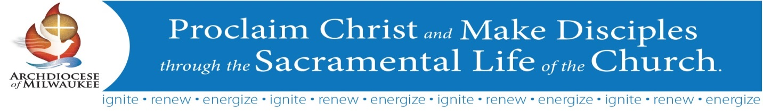
Synod Implementation – Ongoing Strategies
Your feedback is very important to us and we appreciate you taking the time to respond to the following questions. Please return this sheet to Randy Nohl, nohlr@archmil.org.

Parish/Cluster/School/Catholic Organization:___________________________________________

City:____________________________________________________________________________

Evangelization and the Sunday Mass

Over the past year, the Archdiocese has provided a number of resources regarding Evangelization and the Sunday Mass. Please indicate which of the following resources have been helpful:

- Catholic ID cards (adult, children and Spanish)
- #iEvangelizeMke cards (“Invest and Invite: How to Introduce Jesus and His Church”)
- Mass - The Heart of the Matter video
- A New Mission for Missionary People video
- A Vision for the Future: Evangelization and the Sunday Mass booklet
- Synod Implementation Newsletters (Bulletin inserts - every-other month)
- Discussion questions for staff and councils centered on Synod implementation newsletters
- Leadership Gatherings – Friday, September 30 & Saturday, October 1, 2016

- What have been the most helpful of these resources?

- How have they been used in your parish/cluster, school or organization?

- What are other resources or new and unique strategies your parish/cluster, school or organization has implemented in the area of Evangelization and the Sunday Mass?

- Additional Comments

Spirituality of Stewardship

Building upon Evangelization and the Sunday Mass, our focus will be expanding around Spirituality of Stewardship. Consider the following discussion starters:

- What does your parish/cluster, school or organization do well in the area of Stewardship?

- What are new approaches or strategies your parish/cluster, school or organization could consider for further developing the area of Stewardship?

- How can the Archdiocese be of assistance to you regarding the area of Stewardship?

- Additional Comments

Looking ahead to next year’s calendar – SAVE THE DATE!

As you plan for next year, you may want to consider having leaders attended the programs listed below.

Everyday Stewardship: Inspiring and Practical Insights on Stewardship as a Way of Life
Tracey Welliver Director of Parish Community and Engagement for Liturgical Publications Inc. (LPi) and author of the book, Everyday Stewardship: Reflections for the Journey. Tracy is a dynamic Catholic speaker, author, teacher, and stewardship coach with over 20 years of experience in parish ministry.

Tuesday, February 7, 2017 – 6:30-8:00 p.m. – St Patrick Parish, Elkhorn
Wednesday, February 8, 2017 - 6:30-8:00 p.m. - Archbishops Cousins Catholic Center, St. Francis
Thursday, February 9, 2017 – 6:30-8:00 p.m. – Holy Family Parish, Fond du Lac

Spirituality of Stewardship - Leadership Conference
This conference will include prayer with Archbishop Listecki, a keynote presentation on the Spirituality of Stewardship and workshops led by nationally known presenters.

Friday, November 3 and repeated Saturday, November 4, 2017
Tentative Time – 8:30 am-12:30 pm
Archbishop Cousins Catholic Center, St. Francis

