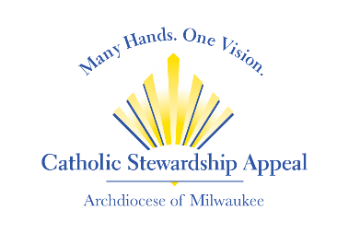

**CSA 2023 Bulletin Announcement Options**

Make a difference in your community with a gift to the **Catholic Stewardship Appeal.** Your gift of any size will impact countless lives. To donate, **text APPEAL2023 to 414-348-8380**, give online at **www.catholicappeal.org** or mail your contribution to the Catholic Stewardship Appeal, 3501 S. Lake Drive, St. Francis, WI 53235. Thank you!

YOU can help build Catholic life in your own community and beyond with a gift to the **Catholic Stewardship Appeal.** Your gift or pledge of any size is needed today. To donate, **text APPEAL2023 to 414-348-8380**, give online at **www.catholicappeal.org** or mail your contribution to the Catholic Stewardship Appeal, 3501 S. Lake Drive, St. Francis, WI 53235. Thank you!

Have you seen the **2023 Catholic Stewardship Appeal video** yet? It is powerful! Navigate to [www.catholicappeal.org](http://www.catholicappeal.org) to watch the video and see how your gift of any size helps so many people and ministries. To donate, **text APPEAL2023 to 414-348-8380**, give online at **www.catholicappeal.org** or mail your contribution to the Catholic Stewardship Appeal, 3501 S. Lake Drive, St. Francis, WI 53235.

Your gift to the **Catholic Stewardship Appeal** supports the many ministries of the Archdiocese. Every gift is needed and welcomed no matter the size. To donate, **text APPEAL2023 to 414-348-8380**, give online at **www.catholicappeal.org** or mail your contribution to the Catholic Stewardship Appeal, 3501 S. Lake Drive, St. Francis, WI 53235. Thank you!

Your support of the **Catholic Stewardship Appeal** supports our youth as they draw closer to Christ through education on the beauty of our Catholic faith. To donate, **text APPEAL2023 to 414-348-8380**, give online at **www.catholicappeal.org** or mail your contribution to the Catholic Stewardship Appeal, 3501 S. Lake Drive, St. Francis, WI 53235.

Now is a great time to strengthen our Catholic presence and bring the joy of knowing Christ to all. Support the **Catholic Stewardship Appeal** and make your gift or pledge today! Every gift no matter the size helps. **Text APPEAL2023 to 414-348-8380**, give online at **www.catholicappeal.org** or mail your contribution to the Catholic Stewardship Appeal, 3501 S. Lake Drive, St. Francis, WI 53235. Thank you!

Join us as we work toward our parish goal of $___________. To date, we’ve raised ____% of the goal from _____ parishioners. Every gift is needed no matter the size. To help us reach our goal, **text APPEAL2023 to 414-348-8380**, give online at **www.catholicappeal.org.**