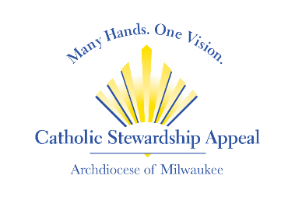

CSA 2024 Bulletin Announcement Options

Bulletin Ad #1
Your gift to the Catholic Stewardship Appeal does God’s work. Your gift of any size will impact countless lives. To donate, visit www.catholicappeal.org, text APPEAL2024 to 414-348-8380 or mail your check to the Catholic Stewardship Appeal, 3501 S. Lake Drive, St. Francis, WI 53235.

Bulletin Ad #2
Scan to see the 2024 Catholic Stewardship Appeal video and learn how your gift does God’s work in the Archdiocese of Milwaukee. To donate, visit www.catholicappeal.org, text APPEAL2024 to 414-348-8380 or mail your check to the Catholic Stewardship Appeal, 3501 S. Lake Drive, St. Francis, WI 53235.

Bulletin Ad #3
Your gift to the Catholic Stewardship Appeal supports many ministries of the Archdiocese. Every gift is needed and welcomed no matter the size. To donate, visit www.catholicappeal.org, text APPEAL2024 to 414-348-8380 or mail your check to the Catholic Stewardship Appeal, 3501 S. Lake Drive, St. Francis, WI 53235.

Bulletin Ad #4
Join us as we work toward our CSA parish goal of $___________. To date, we’ve raised ____% of the goal from _____ parishioners. Every gift is needed no matter the size. To help us reach our goal, give online at www.catholicappeal.org or text APPEAL2024 to 414-348-8380.

