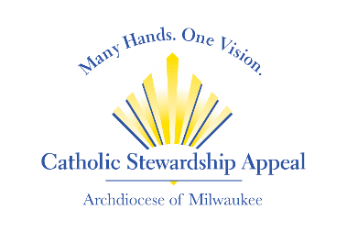

Catholic Stewardship Appeal 2024 Intercessions
include throughout the year as part of your parish’s special intentions
to remind parishioners of the impact of their Appeal gifts

- For our parish community to share our gift of service and financial support for the Catholic Stewardship Appeal, let us pray to the Lord.

- For all of us to give faithfully and graciously to support the Catholic Stewardship Appeal, let us pray to the Lord.

- For those in need who benefit from our support of the Catholic Stewardship Appeal, let us pray to the Lord.

- For a greater evangelization, bringing more souls to Christ and our Catholic faith because of the resources provided through the Catholic Stewardship Appeal, let us pray to the Lord.

- For our parish <<Parish Name>> to continue to grow and thrive because of the many resources offered through the Catholic Stewardship Appeal, let us pray to the Lord

- For the seminarians studying at St. Francis de Sales Seminary. May they continue to grow in their service to Christ and the church through funding provided by the Catholic Stewardship Appeal, let us pray to the Lord.

- For the men answering the call of Christ to become deacons in our church. May they receive the training and resources needed through support provided by the Catholic Stewardship Appeal, let us pray to the Lord.

- For the youth of our parish and our community to grow closer to Christ through the programs and educational opportunities funded by the Catholic Stewardship Appeal, let us pray to the Lord.

- For all of us to humbly accept the challenge to support the Catholic Stewardship Appeal from our substance rather than from our surplus, let us pray to the Lord.

- For the desire to share our gifts for the good of our Catholic community through the ministries and outreach of the Catholic Stewardship Appeal, let us pray to the Lord.

- For the success of the Catholic Stewardship Appeal and it’s work to further God’s mission – our mission – in the Archdiocese of Milwaukee, let us pray to the Lord.

- For all of God’s people who benefit from the Catholic Stewardship Appeal: the elderly, the poor, the sick, priests in formation, the young, new parents, families, the lost and the lonely, let us pray to the Lord.

- For an awareness of God’s generosity to us as we in turn support the Catholic Stewardship Appeal in gratitude, let us pray to the Lord.

- For the members of our parish and our broader Catholic family to unite and fully support the Catholic Stewardship Appeal, let us pray to the Lord.

