Come Alive!
with
Jesse Manibusan
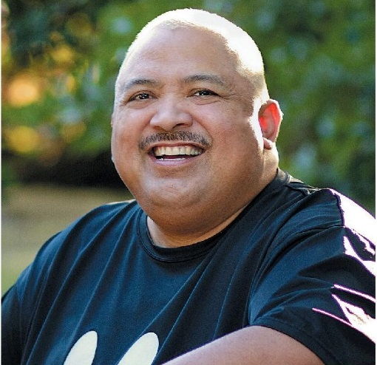

The parishes of St. Matthew and St. Mary by the Lake invite you to a series of days set aside for prayer, reflection, and inspiration. Join us as we build our communities through music and presentations that are fun and accessible to everyone.

Wednesday, March 11
6:30 pm Mission with Jesse

Thursday, March 12
9:00 am Mass followed by session with Jesse
6:30 pm Mission with Jesse

Friday, March 13
9:00 am school Mass followed by session with Jesse
6:30 pm Mission with Jesse

All events will be held at St. Matthew Parish
9303. S. Chicago Road, Oak Creek

Free-will offerings will be accepted

Jesse Manibusan is a singer, songwriter, guitarist, and teller of humorous tales. Well recognized as a dynamic and eclectic speaker and musician, Jesse shares from his heart his love of Christ and the call to live our baptism in every aspect of life.

