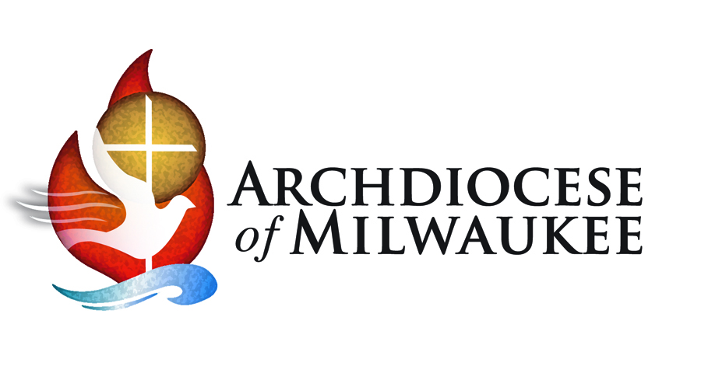
Spirituality of Stewardship
Archbishop Jerome E. Listecki

Following the archdiocesan Synod, I asked that from time-to-time we “shine a spotlight” on top priorities that came from the Synod. We have been focusing on Evangelization and the Sunday Mass for a little over a year and have seen more emphasis being placed on inviting people to Mass and helping parishes to focus on moving from “maintenance to mission.”

If we are serious about moving from a maintenance approach to mission focused ministry, we need to continue to develop the area of Evangelization and the Sunday Mass while expanding our focus to other areas as well. With this in mind, we will be “shining the spotlight” on the Spirituality of Stewardship in the New Year.

Many of you are familiar with my top three priorities - Catholic Identity is Who we are, Evangelization is What we do, and Stewardship is How we do it. Stewardship is how we use our time, gifts and financial resources to further the mission of the Church.

Stewardship isn’t just about giving money. Stemming from each individual’s personal relationship with the Lord, true stewardship is not about what we do, but rather about who we are. It defines a way of life for intentional disciples.

Each human being has been given a unique set of gifts; family and friends, interests and talents, material goods and financial resources. Faithful stewards are continually making conscious decisions about how these gifts, even those that have increased through hard work and individual diligence, will be shared with others and returned to the Lord.

At first glance, returning gifts with increase to the Lord can be difficult to grasp. Obviously, God does not need our talents, money or other resources. Yet, we are called to build his kingdom here on earth through good works and active ministry.

Whether we are sharing our time, talents, or material resources, we are extending ourselves, and becoming instruments of Christ in this world. We give great praise to God, the giver, by sharing our gifts gratefully in justice and love with others.

Focusing on the mission Jesus gave us, stewardship and giving of ourselves, is how we form ourselves as intentional disciples. I look forward to exploring this area with you further throughout the year.

Everyday Stewardship – Inspiring and Practical Insights on Stewardship as a Way of Life
Tuesday, February 7 – 6:30-8 pm – St. Patrick, Elkhorn
Wednesday, February 8 – 10-11:30 am & 6:30-8 pm – Cousins Center, Milwaukee
Thursday, February 9 – 6:30-8 pm – Holy Family, Fond du Lac

For more details or to register – www.archmil.org/synod or Randy Nohl, nohlr@archmil.org or 414-758-2216

