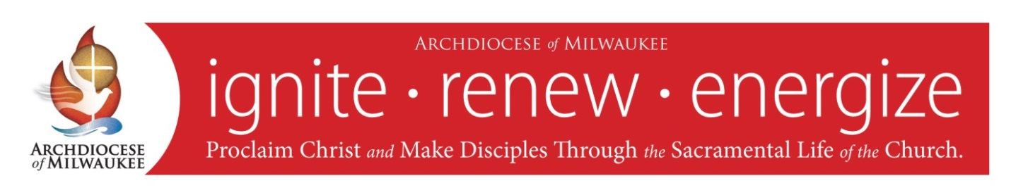

**Prayer for the Mission of the**

**Archdiocese of Milwaukee**

Almighty and ever living God,

we praise you and we bless you,

for you are great indeed!

Grant, we pray,

as on that first Pentecost,

that tongues of fire may descend upon us,

and that the driving wind of your Holy Spirit

may blow boldly into our hearts.

Loving God, we ask you,

make us effective and holy witnesses

of the death and resurrection

of your Son, Jesus Christ,

increase our faith

through the sacramental life of the Church,

grant us courage to follow you

as faithful disciples.

Embolden us, O God,

so that we may go forth to proclaim

your Gospel and renew the face of the earth.

In this Archdiocese of Milwaukee,

we humbly pray for strength and fortitude

to follow your great commission:

to go and make disciples of all people,

living our faith through word and deed.

Through the intercession of St. John the

Evangelist, patron of the archdiocese,

and Mary, Mother of the Church,

we ask all this through Christ our Lord.

Amen.

Printed with Ecclesiastical Permission