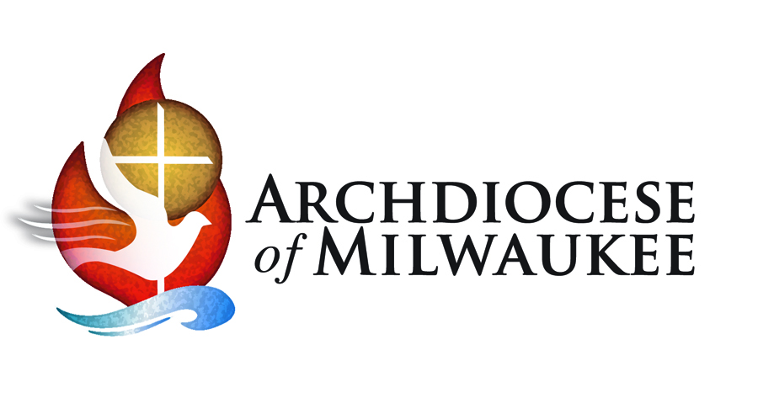
Stewardship & Evangelization – the Chicken or the Egg?

Most Reverend Jerome E. Listecki
Archbishop of Milwaukee

At one time or another, you have probably heard the saying, “which comes first – the chicken or the egg?” You may have even used this adage when you were discussing something and weren’t sure where to begin or the process of how something got started.

In church circles, there are some people who have the “chicken and egg” discussion regarding stewardship and evangelization. One school of thought tells us that stewardship leads to evangelization. Another way of thinking emphasizes that evangelization must come before stewardship.

As I have said many times, my top priorities are Catholic Identity (who we are), Evangelization (what we do) and Stewardship (how we do it). So, while no one can definitively answer the question of which comes first – the chicken or the egg – I can tell you for sure that you need both!

Perhaps we might be wise to consider stewardship and evangelism as two branches of our faith “tree.” Both flow from embracing our faith fully – the gifts and the responsibilities – and then acting accordingly. Both call us to share all we have: our time, our talents, our resources and our faith, as we do our part to live as God intended, and invite others to do the same. Stewardship and Evangelization – one does not exist without the other.

Those involved with stewardship understand that the most important goal of stewardship formation is deepening our relationship with Jesus so that we can live more faithfully as his disciples in the world. In other words, the ultimate goal of stewardship formation is evangelization. When our faith lives are alive and on fire, we cannot help but share our love of Jesus with others.

We also understand that evangelization is central to the mission of all we do as Church. Through evangelization, we come to know, and to share, the Good News of Jesus Christ. Evangelization, simply stated, is encountering Jesus, embracing his call to discipleship, and sharing that call with others.

Disciples who practice stewardship as a way of life recognize God as the source of all they have, are, and will be. Good stewards recognize the most precious gift given by our gracious and generous God is the gift of faith and they recognize that this gift must be shared with others in our faith community and the larger world.

So, it’s not as important which came first as it is that we are faithful disciples whose lives are rooted in Catholic Identify, Evangelization and Stewardship.

What does this mean for me?
- Stewardship and evangelization call us to share all we have – “our time, our talents, our resources and our faith.” When have I witnessed someone truly doing that?

- Archbishop Listecki states that the goal of stewardship is to deepen one’s relationship with Jesus in an effort to “live more faithfully as his disciples.” What have I been doing or could I do to deepen my relationship with Jesus?

