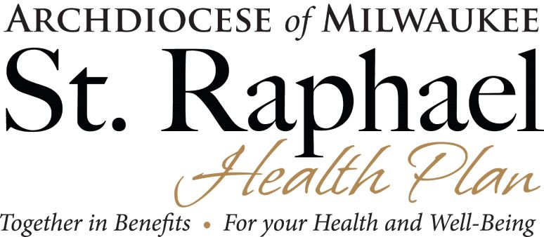

IMPORTANT BENEFITS INFORMATION & REMINDERS

Your Aetna Medicare Advantage (PPO) Plan, your Delta Dental plan, and your VSP Vision plan (if you have one) will renew automatically on January 1, 2024. You do not have to do anything to make that happen!

The deadline to request reimbursement of up to $1,000 of eligible medical expenses under the Health Reimbursement Account (HRA) for the previous Plan year (July 1, 2022, thru June 30, 2023), is September 28, 2023. You may submit your expenses online at www.dbsbenefits.com after logging in to your account, or in hardcopy by completing the attached claims form and mailing it along with a list of your expenses and the corresponding receipts to Diversified Benefit Services, P.O. Box 260, Hartford, WI 53029. A list of eligible expenses is attached.

The Health Reimbursement Account is moving from a fiscal-year administration to a calendar-year administration effective January 1, 2024. This means we will have a “short” plan year (7/1/2023 thru 12/31/2023) to finish out this year. The amount you will have access to is also adjusted to $500 per IRS regulations. Expenses for this “short” plan year must be submitted by March 28, 2024. More information and reminders will follow as we get closer to these dates and deadlines. Once the new calendar year plan begins in January 2024, you will again have access to the $1,000 maximum.

Please contact Maureen Wurster, HR and Benefits Administrator, at 414-769-3423 or wursterm@archmil.org if you have any questions.

