

Dear Mr. & Mrs. Baldus,

It is with happiness and joy that I congratulate you on Luella’s baptism. On behalf of the full Catholic community of southeastern Wisconsin, I warmly welcome your child as the newest member of God’s loving family.

As your child grows, my prayers will continue to be with you as you encounter the challenges and joys of being a Catholic parent, teaching and inspiring your child to live a life like Christ by following our Catholic traditions.

As you may have already discovered, Luella’s baptism is an important moment in life. The celebration of this special sacrament extends to the entire parish as well, whose members proudly welcome your child to the faith community.

May God bless you and your family abundantly!

In His Name,


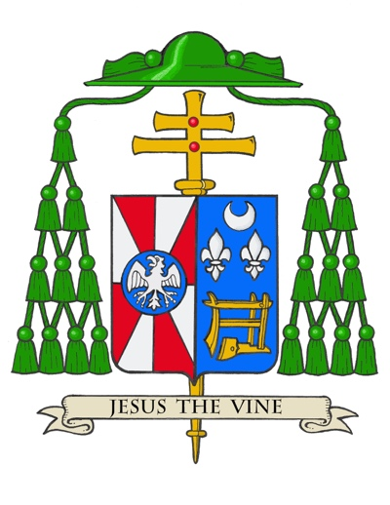
Most Reverend Jeffrey S. Grob
Archbishop of Milwaukee

“God the Father of our Lord Jesus Christ has freed you from sin,
given you a new birth by water and the Holy Spirit,
and welcomed you into his holy people.”

- From the Rite of Baptism

