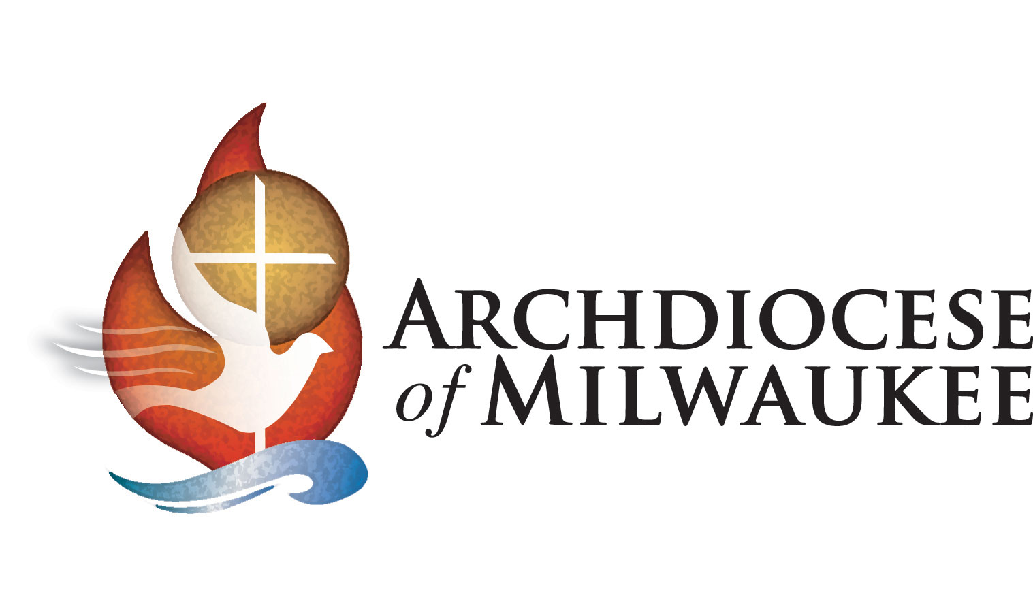

Dear (NAME OF CONFIRMAND),
By accepting the sacrament of confirmation this year, you are receiving a special gift that God calls you to look after. The gift of the Holy Spirit will always guide you if your heart is open and it will give you the courage to live your life for Jesus Christ. This is truly a gift that is better than any other you will receive on this most special of days.
In coming to know the young people who reside in the Archdiocese of Milwaukee, I have been deeply moved by your passion for the Catholic faith and the strong sense of the Holy Spirit that dwells among you. As you have prepared for this sacrament, I hope your knowledge of the faith has deepened even more, and your sense of Christian duty has been enriched.
Congratulations on your confirmation, and may God bless you most abundantly through all phases of your faith journey.

In His Name,

Most Reverend Jeffrey S. Grob
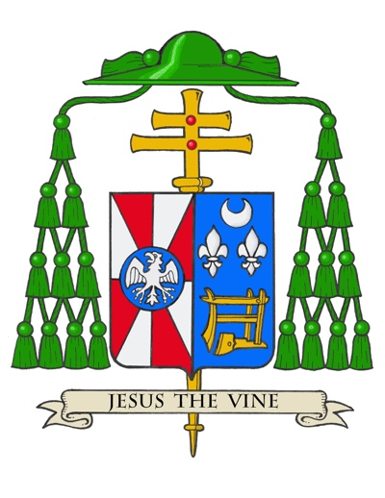
Archbishop of Milwaukee

"I sign thee with the sign of the cross and confirm
thee with the chrism of salvation,
in the name of the Father and of the Son
and of the Holy Ghost."
– From the Confirmation Ritual

