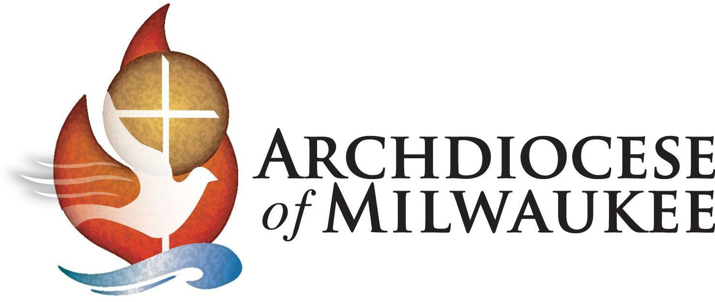

May 2021

Dear **Name of Child HERE**,

By receiving first holy Communion, you are finally “coming to the table of the Lord.” Let me tell you, this is no ordinary meal! Because of all the special graces we receive, it is so important that you continue to go to church often and receive God’s special grace in holy Communion.

As you were taught this year, Jesus Christ, who shared God’s love, forgave sins, cured the sick, who died on the cross and rose from the dead, is the same Jesus, Body and Blood, that we receive in holy Communion at each and every Mass.

I am so proud of you at this time of your first Communion. May God continue to bless you and your family, each and every day.

In His Name,

Most Reverend Jeffrey S. Grob Archbishop of Milwaukee

“Blessed are you, Lord, God of all creation. Through your goodness we have this bread to offer, which earth has given and human hands have made. It will become for us the bread of life.”

*– From the Communion Rite*