

Dear (NAME OF BRIDE AND GROOM),
When you first became engaged, it might have been easy to have become overwhelmed with the many details that came along in planning a wedding. Oftentimes, those plans had the tendency to take precedence over the true meaning of that day: the beginning of your marriage! Now that you are married, you may discover a whole new chapter in your life as husband and wife, one which comes with both difficulties and joys.
I want you to remember that the Church is always here to support you in your love for one another. On behalf of the full Catholic community of southeastern Wisconsin, I tell you most sincerely that we celebrate with you this holy union to which you have committed yourselves. In receiving the sacrament of marriage, you are blessed by God in a very special way.
I wish you many joys in your marriage, especially love, fidelity and joy. May God be with you through all phases of your new life together.

In His Name,

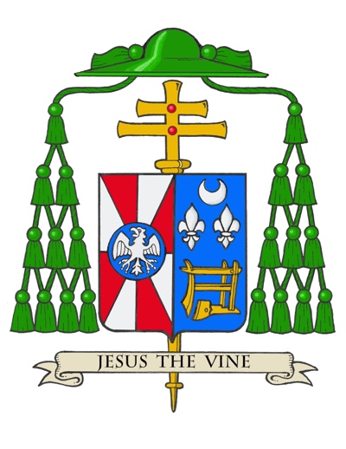
Most Reverend Jeffrey S. Grob
Archbishop of Milwaukee

“May the Lord in his goodness strengthen your consent
and fill you both with his blessings.
What God has joined, men must not divide.”

– From the Rite of Marriage Nuptial Blessing

