

Dear (NAME),
I am so happy you have decided to become an active member of (PARISH NAME). The parish is where our faith is nourished, where we come together to share beliefs and support one another, where we bring both our strengths and our weaknesses. Parish life and community worship strengthen us to carry our faith into everyday relationships, challenges, joys and encounters. The parish is our spiritual family.
On behalf of the full Catholic community of southeastern Wisconsin, I celebrate with your parish the wonderful addition of you as a member. Your gifts and talents are important to the faith community. I hope you will share them with your fellow parishioners.
I pray that your faith life will be enhanced through your relationship with God and his faith-filled family at (PARISH NAME).

In His Name,

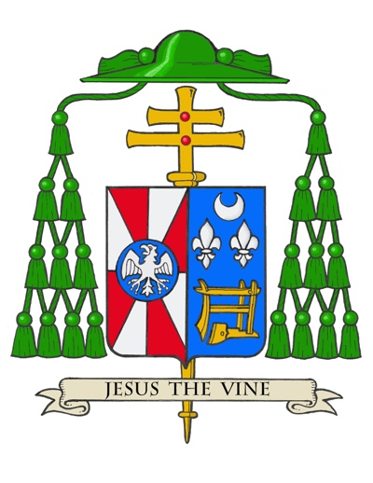
Most Reverend Jeffrey S. Grob
Archbishop of Milwaukee

“And the peace of God, which transcends all understanding,
will guard your hearts and your minds in Christ Jesus.” (Phil 4:7)

