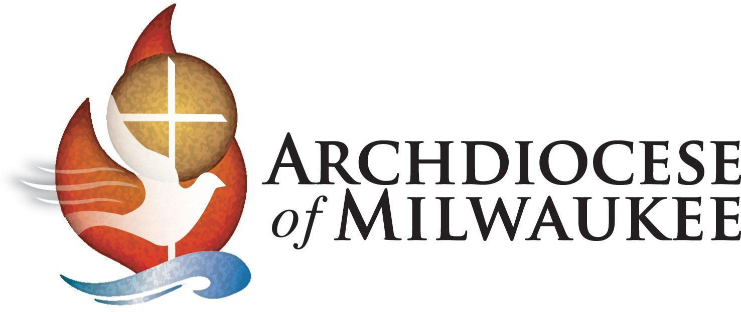

Dear **Name of Parent(s) Here**,

By receiving the sacrament of reconciliation for the first time, **Name of Child Here** is taking a most important step in this journey of faith. Our Catholic Church is a sacramental church, and this sacrament of reconciliation is a wonderful gift that Christ has given to us. It is a gift of forgiveness and second chances, of knowing we can begin our life anew. It is a gift of hope as we grow stronger in living God’s will, and a precious gift of faith in renewing our commitment to be followers of Christ.

I encourage you to help **Child’s Name** appreciate the sacrament of reconciliation by modeling how important it is in your own faith life and by ensuring that he continues to receive the sacrament on a regular basis.

May God continue to bless your family abundantly as you all continue on your faith journey.

In His Name,

Most Reverend Jeffrey S. Grob Archbishop of Milwaukee

“The Lord has freed us from sin.

May he bring us safely to his kingdom in heaven. Glory to him forever.”

*–Proclamation of Praise from the Rite of Penance*