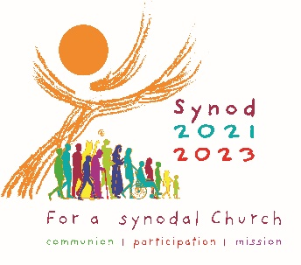

Pope Francis wants your opinion!

Lend your voice to the Archdiocese of Milwaukee's response to Pope Francis' Synod on Synodality! What would you like the Archdiocese of Milwaukee, and Pope Francis to know?

Tell us a little bit about you.

Name: _________________________________________________

Email address (optional): ___________________________________________

The southeastern Wisconsin county in which you reside:

- Milwaukee County
- Waukesha County
- Ozaukee County
- Sheboygan County
- Dodge County
- Walworth County
- Racine County
- Kenosha County
- Fond du Lac County
- Other: _____________________

Age:

- Under 18
- 18-22
- 23-30
- 31-40
- 41-50
- 51-60
- 61-70
- 71-80
- Over 81

Race:

- Asian
- Black or African American
- Native American
- Pacific Islander
- White
- Other: ________________________

Ethnicity:
- Hispanic or Latino
- Non-Hispanic or non-Latino

Sex:
- Male
- Female

Are you a baptized Catholic?
- Yes, as an infant
- Yes, as an adult or I became Catholic as an adult
- Yes, but I no longer consider myself Catholic
- No

What is your current religion?

- Catholic
- Protestant
- Jewish
- Muslim
- Agnostic
- Atheist
- None
- Other: ______________________

If you were baptized Catholic, and no longer consider yourself Catholic, how do you describe yourself?
- I joined another Christian church
- I joined a non-Christian church
- I no longer practice any religion
- I got out of the habit
- Other: _______________________________

If applicable, why did you leave the Catholic faith?

How frequently do you attend Catholic Mass?
- Daily
- More than once a week
- Weekly
- Once or twice a month
- Weddings and funerals
- Christmas and Easter
- Seldom
- Never

What parish community do you call “home?”

Tell us a little about your faith.

How would you describe your relationship with God?

Who is Jesus Christ for you?

How do you encounter Jesus in your life?

How could the Church help you to come to know Jesus more deeply, and help you in your faith journey?

How would you describe your relationship with the Catholic Church?

I believe my voice matters in the Church (please circle).

5  Strongly Disagree | 4  Disagree | 3  Neutral | 2  Agree | 1  Strongly Agree

Share your thoughts and ideas with us.

I believe the Catholic Church helps those in need and those on the margins.

5  Strongly Disagree | 4  Disagree | 3  Neutral | 2  Agree | 1  Strongly Agree

What are the two biggest challenges facing people in southeastern Wisconsin?

1.

2.

Where and how is the Gospel being lived and preached effectively in the Archdiocese of Milwaukee? When do we journey together well? What examples do you see?

In the Archdiocese, when are times and occasions when the Gospel is NOT being lived out and preached effectively? When do we fail to listen or fail to journey with people? How can we grow?

How can the Catholic Church better journey together with you and others? What steps does the Holy Spirit invite us to take in order to grow in our “journeying together?”

If you could share one thing with Pope Francis, what would it be?

