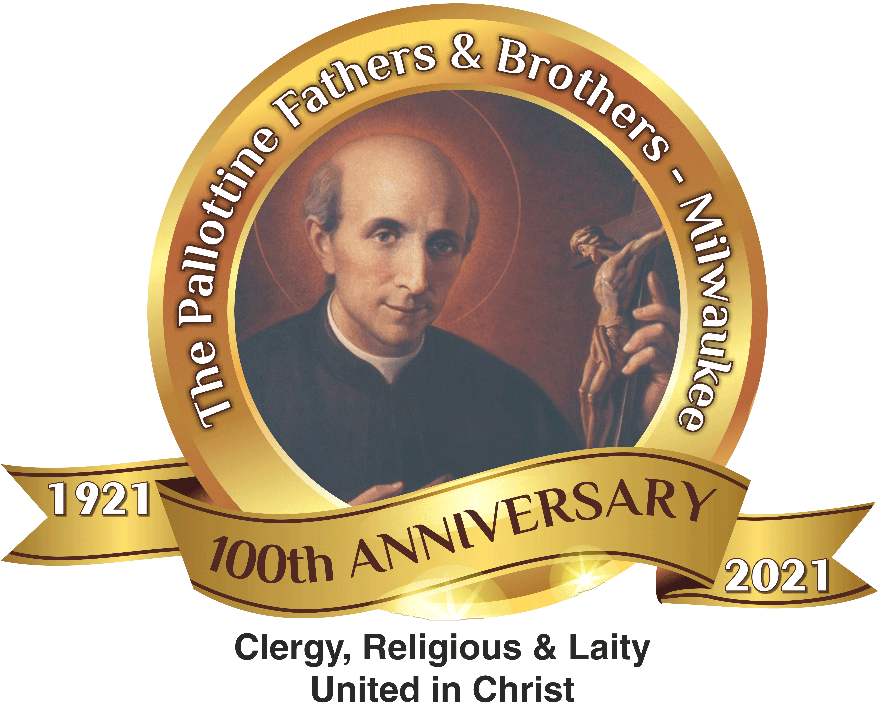

Pallottine Fathers and Brothers
Serving the Poor Around the World

Our Ministry
The Pallottine Fathers and Brothers is a religious community of Catholic priests and brothers founded by St. Vincent Pallotti in 1835. Dedicated to spreading the faith and bringing God’s infinite love to the poor, the Pallottines serve in 57 countries around the world, including the United States. In 2021, the Pallottines are celebrating 100 years of ministry in the Archdiocese of Milwaukee, Wisconsin, and serving in 21 parishes in southern Wisconsin and northern Illinois.

Our Mission Focus Abroad
- Arunachal Pradesh, India
The people of India need a Boarding Home for girls and a Village Chapel.
- Boarding Home for 75 girls: $75,000
- Village Chapel: $15,000
Pallottines are committed to evangelizing the tribal people living primitively in the foothills of the Himalayas. With 13 priests and 80 villages, priests sometimes walk for 2-3 days on foot, encountering landslides and challenging vertical terrain, to celebrate sacraments, catechize children, and encourage women involvement. To meet the needs of the growing faithful, Pallottines hope to construct one village chapel per year. We need $15,000 to build one village chapel with a sturdy roof and long-lasting materials like brick for 100 parishioners. To promote the importance of girls receiving an education, the Pallottines hope to build a Boarding Home for 75 more girls. With parents being uneducated and financially impoverished, we need $1,000 per year for each female student to provide an education, living expenses, and catechesis.
- Zambia, Africa
The people of Zambia need a Health Clinic and a Seminary/Seminarian Fees.
- Health Clinic: $60,000
- Seminary and 5 Seminarian Fees: $124,000
At the Pallottine’s Marian Health Post, one Pallottine Sister who is a certified nurse, along with an aide, have provided care for 7,312 sick out of one small room during the past 3 years. Cramped for space and not having the proper medical facilities, the Pallottines want to build a Health Clinic to better help people with HIV/AIDS and other illnesses. $25 gives 100 people much-needed medical check-ups. $60,000 can build a Health Clinic with hospital beds, ultrasound machines, a pharmacy, and multiple consultation rooms with an indoor waiting area. To train priests native to the area, the Pallottines hope to build a Seminary and offer scholarships to 5 seminarians to cover their $4,800 yearly expenses for living and tuition costs. A seminary would need to be built for $100,000 to accommodate more seminarians.

