Sample Pastor/Parish Director Letter
November 7, 2011

Parish Name
Pastor/Parish Director
Parish Address:
Parish Address Line 2
Parish City, State Zip Code

Dear Pastor/Parish Director
As you know, the Archdiocesan Priest Council approved a proposal for a second collection for La Sagrada Familia parish for three years subject to evaluation at the end of the third year, 2013. Thank you for your willingness to have a second collection in support of our archdiocesan sister parish on December 10-11, 2011. The Archdiocesan Priest Council chose this weekend for the collection because of its proximity to the Feast of Our Lady of Guadalupe, patroness of the Americas.
Before 1981 there was no parish church in the Province of Azua in the Dominican Republic, only a young diocese with people living in the poorest section of the country near the Haitian border, praying for someone to accompany them on their faith journey. In choosing to begin this relationship, the Archdiocese of Milwaukee committed itself to providing priests to minister and to becoming a partner with the people in building a community of faith and mutual friendship.
In these thirty years, 14 priests from our archdiocese have served the parish. Social as well as pastoral ministries have been developed to meet the needs of the people. Thanks to the support of our archdiocese there is a parish church, a small parish staff, a health center, two nutrition centers for malnourished children, 22 villages with several small chapels and a growing population of 30,000 people. The growth of the parish includes the development of bonds of relationship that have formed between people in La Sagrada Familia and parishioners from our archdiocese.
The continued growth of our relationship with La Sagrada Familia parish depends to a great extent upon archdiocesan awareness of the life and changing needs of the people of the parish and upon a generous personal and financial response to those bonds of relationship. To facilitate this awareness and response, World Mission Ministries is providing the following resources to assist you in this effort:
  - Homily Helps prepared by Bishop Richard J. Sklba
  - Brief pulpit announcements for Sunday Masses prior to and including December 10-11
  - Envelope and card for parish check (enclosed). Please ask parishioners to address checks to your parish and send one check addressed to Office for World Mission
  - A follow-up email to elicit your feedback and suggestions for the 2nd year of the collection
  - Information cards about La Sagrada Familia for interested parishioners to be delivered to your parish and displayed in pews or the back of church during the weekend of December 10-11 (an example card is enclosed)
  - Specific information prepared for Bulletin editors to assist them in raising awareness of this effort, including stories and images.
  - A webpage containing these resources (and more). Please visit http://www.archmil.org/parishes/Sagrada-Familia/SagradaFamiliaSecondCollection.htm
We count on your leadership and support in raising awareness of our archdiocesan relationship with La Sagrada Familia and encouraging parish participation in this collection as a way of strengthening the bonds of faith and friendship. Please let us know if we can be of further assistance to you.

All Peace and Good to You!

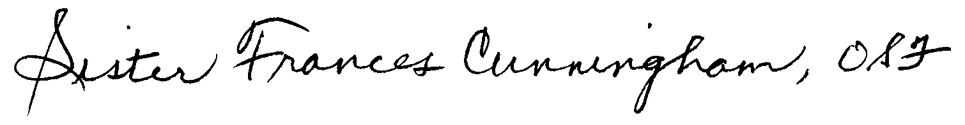
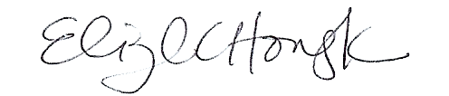
Sister Frances Cunningham, OSF Elizabeth Howayeck

Director International Mission Coordinator

